Press release

Preset ultrasonic sensors for a fast startup

PiL Sensoren GmbH – pioneer of ultrasound technology – has developed the P49 model series for a fast startup. The manufacturer individually parameterizes these sensors to meet customer requirements. This saves users the time they usually need for setting up ultrasonic sensors on site for an application. The savings potential is considerable – especially when it is not just a matter of a few sensors, but a medium to large quantity. The P49 series includes three types of sensors (M18, M30 and cubic 80 mm x 80 mm) for ranges from 30 mm to 6 m, optionally with switch outputs or with current or voltage outputs. With preset, each customer gets their own item number, giving them a unique product that can always be traced back to them. This in turn prevents errors in the field caused by unauthorized or unqualified parameterization. And even if it needs replacing in the field, nothing needs to be adjusted. The plastic sensors with protection type IP67 are suitable for ambient temperatures of -20 °C to 70 °C. They are used in a variety of applications, such as filling level measurement for liquids and bulk goods, in logistics for collision protection and position control, as well as for container inspection, thickness measurement and presence control – for example in the paper, film and textile industries.

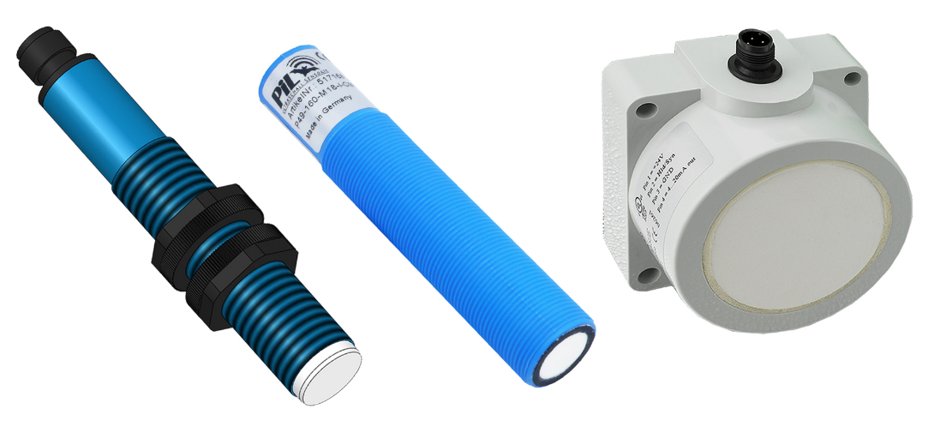

Caption: Preset ultrasonic sensors for a fast startup: Simply install, connect, and you’re ready to go

PiL offers comprehensive application know-how and responds flexibly to customer requirements at all times. And where application-specific parameterization is not sufficient, the manufacturer is also happy to support its customers on request with individually customized solutions. The development and manufacturing facilities of the specialist for industrial ultrasonic sensor technology are in Germany.

Image/s: | p49_voreingestellte_us-sensoren | Characters: | 1,819
File name: | 202109023_pm_P49_voreingestellte_us-sensoren_en | Date: | 10-13-2021
About PiL
PiL Sensoren GmbH, with its headquarters in Erlensee near Frankfurt/Main is a pioneer of ultrasonic technology and has been developing, producing, and selling standard and customized sensor solutions for industrial applications since 1990. Together with Inelta Sensorsystem GmbH & Co. KG (Taufkirchen near Munich) and VYPRO s.r.o. (Trenčín, Slovakia), PiL offers a wide range of products for measuring displacement and position as well as force, pressure, and inclination. The range of products we offer includes force sensors, sensor signal amplifiers, pressure switches, capacitive sensors, and ultrasonic sensors. Our portfolio is nicely rounded off with cable and connector assembly services.
Most of the group of companies’ customers are in industrial automation, mechanical engineering, hydraulics, medical technology as well as the aerospace industry. We especially focus on industry and customer-specific sensor solutions and are constantly expanding this focus with interdisciplinary know-how.

Contact:  PiL Sensoren GmbH  Zweigstelle Süd  Reinhard Koch  Ludwig-Bölkow-Allee 22  82024 Taufkirchen  Phone: 089 / 452 245-0  Fax: 089 / 452 245-744  eMail: marketing@pil.de  Internet: www.pil.de | gii die Presse-Agentur GmbH  Immanuelkirchstraße 12  10405 Berlin  Phone: 030 / 538 965-0  eMail: info@gii.de  Internet: www.gii.de

