Press release

Customer-specific ultrasonic sensors at cost-effective conditions

No other sensor technology has such a versatile range of applications as ultrasonic technology: In the industrial sector alone, its applications range from recording filling levels and volume flows and measuring distances, heights, and widths through to detecting objects and obstacles in dynamic processes. Yet depending on their specific application, sensors often require costly modifications in order to work reliably. Inadequate conditioning of the signals or faulty seals on the housing of standard sensors can not only result in unsatisfactory measurement results but also in the early failure of the sensors.
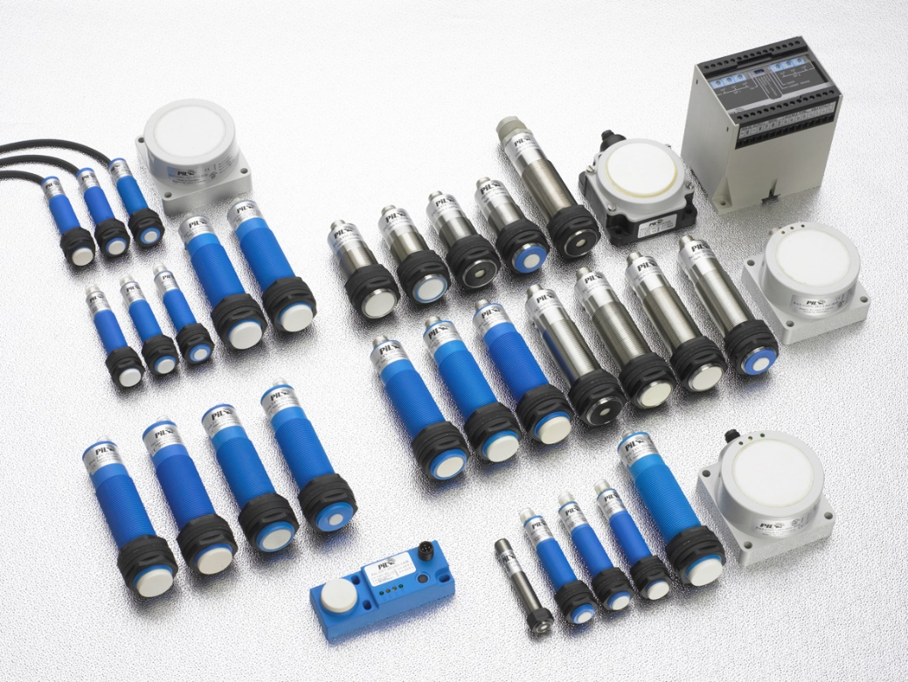
Caption: Ultrasonic sensors (product examples) from PIL

Yet it is usually extremely expensive for companies to commission the production of suitable and appropriately robust sensors. PiL Sensoren GmbH offers its customers a happy medium in the form of cost-effective solutions. Thanks to its own development and production facilities in Germany, this manufacturer of ultrasonic sensors not only specializes in the production of a wide range of robust standard models but can also supply sensors that have been configured for specific applications. Due to its decades of experience in the production and adaptation of customer-specific sensors, PIL can offer a broad range of tried-and-tested solutions. The company’s engineers also use their comprehensive expertise in different fields of application to develop durable sensor solutions for use in challenging operating conditions that offer good value for money. The technical consultants at PIL would be delighted to provide comprehensive advice to any customers who are looking for sensor solutions for their specific requirements.

Image/s: | PIL_Sensorenbaureihen_Pxx | Characters: | 1,646
File name: | 202201010_pm_kundenspezifische_Ultraschallsensoren_en | Date: | 01-26-2022
About PIL
PIL Sensoren GmbH, based in Erlensee near Frankfurt/Main, is a pioneer in the field of ultrasonic technology and has been developing, producing, and selling standard and customized sensor solutions for industrial applications since 1990. Together with Inelta Sensorsystem GmbH & Co. KG (Taufkirchen near Munich) and VYPRO s.r.o. (Trenčín, Slovakia), PIL offers a wide range of products for measuring the displacement and position of an object, as well as force, pressure, and inclination. The range of products we offer includes force sensors, sensor signal amplifiers, pressure switches, capacitive sensors, and ultrasonic sensors. Cable and connector assembly services round off our portfolio.
Our group of companies supplies products and services to customers in the industrial automation, mechanical engineering, hydraulics, medical technology, and aerospace industries. We especially focus on industry and customer-specific sensor solutions, which are constantly enhanced thanks to our interdisciplinary expertise.

Contact:  PIL Sensoren GmbH  Southern Branch  Reinhard Koch  Ludwig-Bölkow-Allee 22  82024 Taufkirchen  Tel.: +49 (0)89 / 452 245-0  Fax: +49 (0)89 / 452 245-744  E-mail: marketing@pil.de  Internet: www.pil.de | gii die Presse-Agentur GmbH  Immanuelkirchstraße 12  10405 Berlin  Tel.: +49 (0)30 / 538 965-0  E-mail: info@gii.de  Internet: www.gii.de

