Press Release

Mounting filling level sensors: tight, hygienic, exchangeable

PiL offers a range of mounting solutions for making ultrasound measurements in closed containers to reliably and precisely detect the contents or filling level even in challenging applications. Depending on the medium, ultrasonic sensors with metric thread can simply be screwed into the housing wall. It must be ensured that no resonance vibrations occur that could falsify the measurement results. This simple screw-in solution does the job for some applications. Elsewhere, more or less elaborate seals are necessary. The sealing material needs to be super tight and hygienic for food and pharmaceutical applications. The sensors are attached with nuts from the inside and outside. This makes it difficult to replace sensors when necessary: The container has to be opened and the locknut can get lost. This is where PiL has developed a special vibration and resonance-free housing which is firmly mounted to the opening in the container wall from the outside. This then means the sensor can be flexibly replaced at any time as required. Absolute tightness guaranteed. This solution is particularly recommended for applications where sensors have short service lives or those in which the medium must not be contaminated. It is used for monitoring liquids as well as bulk solids and is also suitable for foodstuffs, alkalis and acids, among other things. PiL offers this housing for most of its sensor series.

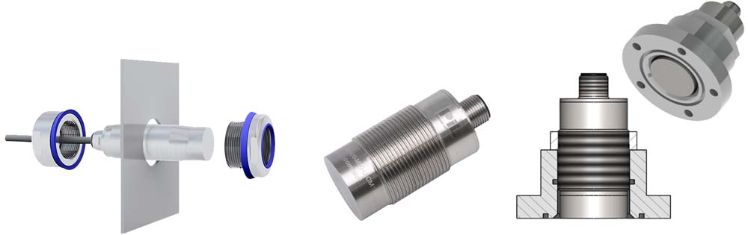
Caption: Ultrasonic filling level sensors that can be screwed in, with a seal or with vibration and resonance-free housing, making it easy to change the sensor and possible log content and filling levels in closed containers without contaminating media

The measurement solution reliability not only depends on the use of robust sensor technology, but also on specific design features of the selected sensor models, their application-specific configuration, and correct placement. That is why PiL, as a specialist for industrial ultrasonic sensor technology, supports its customers with comprehensive application know-how, detailed consultation, and where required, is happy to carry out customized modifications of its products as required.

Image/s: | pil_us_sensor_installation | Characters: | 1898
File name: | 202109020_pm_pil-us-fuellstandsensoren_en | Date: | 09-22-2021
About PIL
PiL Sensoren GmbH, with its headquarters in Erlensee near Frankfurt/Main is a pioneer of ultrasonic technology and has been developing, producing, and selling standard and customized sensor solutions for industrial applications since 1990. Together with Inelta Sensorsystem GmbH & Co. KG (Taufkirchen near Munich) and VYPRO s.r.o. (Trenčín, Slovakia), PiL offers a wide range of products for measuring displacement and position as well as force, pressure, and inclination. The range of products we offer includes force sensors, sensor signal amplifiers, pressure switches, capacitive sensors, and ultrasonic sensors. Our portfolio is nicely rounded off with cable and connector assembly services.
Most of the group of companies’ customers are in industrial automation, mechanical engineering, hydraulics, medical technology as well as the aerospace industry. We especially focus on industry and customer-specific sensor solutions and are constantly expanding this focus with interdisciplinary know-how.
Contact:  PIL Sensoren GmbH  Zweigstelle Süd  Reinhard Koch  Ludwig-Boelkow-Allee 22  82024 Taufkirchen  Germany  Phone: +49 89 / 452 245-0  Fax: +49 89 / 452 245-744  Email: marketing@pil.de  Internet: www.pil.de |  | gii die Presse-Agentur GmbH  Immanuelkirchstr. 12  10405 Berlin  Germany  Phone: +49 30 / 538 965-0  Email: info@gii.de  Internet: www.gii.de

