Press release

Measuring around corners with ultrasonic sensors

Ultrasonic sensors always emit their sound waves “straight forwards” by nature. However, the spatial conditions and installation location make it difficult to directly align the sensor housing with the object being monitored in many applications. Redirecting the sound waves using suitable angled reflectors is a practical solution for this problem.

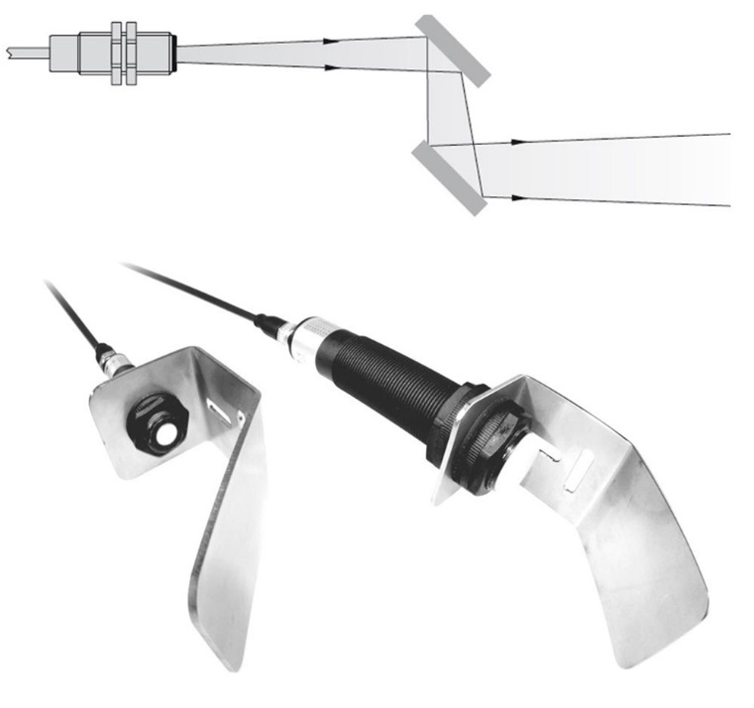
Figure 1: PiL offers tried-and-tested solutions for applications in which the ultrasonic sensors cannot be directly aligned with the object being monitored.

For example, it is not possible to make new installation openings for ultrasonic sensors in many containers whose interiors needs to be monitored. In these cases, the sensors can simply be fitted parallel to the wall of the container on terminal blocks and the sound waves emitted from the sensors can be redirected through an existing opening using 90° reflectors. PiL Sensoren, a leading specialist for ultrasonic sensors, offers tried-and-tested solutions and a comprehensive range of mounting accessories for these types of application. Alongside ultrasonic sensors suitable for every requirement, the PiL product range includes optimally aligned 90° plastic reflectors, focusing attachments, and flexible metal reflectors for adjusting the angle of the sound wave to the specific requirements of the application. If you have any specific requirements, please contact the application consultants at PiL. You will find contact details at www.pil.de/kontakt.

Application know-how is key
The reliability of measurement solutions not only depends on the use of robust sensor technology, but also on specific design features of the selected sensor models, their application-specific configuration, and correct placement. That is why PiL, as a specialist for industrial ultrasonic sensor technology, supports its customers with comprehensive application know-how, detailed consultation, and where required, is happy to carry out customized modifications of its products as required.

Figures: | Ultraschallsensor_mit_Reflektor | Characters: | 1,829
File name: | 202202010_pm_ultraschall_um_die_ecke. | Date: | 02-22-2022
About PIL
PIL Sensoren GmbH, based in Erlensee near Frankfurt/Main, is a pioneer in the field of ultrasonic technology and has been developing, producing, and selling standard and customized sensor solutions for industrial applications since 1990. Together with Inelta Sensorsystem GmbH & Co. KG (Taufkirchen near Munich) and VYPRO s.r.o. (Trenčín, Slovakia), PIL offers a wide range of products for measuring the displacement and position of an object, as well as force, pressure, and inclination. The range of products we offer includes force sensors, sensor signal amplifiers, pressure switches, capacitive sensors, and ultrasonic sensors. Cable and connector assembly services round off our portfolio.
Our group of companies supplies products and services to customers in the industrial automation, mechanical engineering, hydraulics, medical technology, and aerospace industries. We especially focus on industry and customer-specific sensor solutions, which are constantly enhanced thanks to our interdisciplinary expertise.

Contact:  PIL Sensoren GmbH  Southern Branch  Reinhard Koch  Ludwig-Bölkow-Allee 22  82024 Taufkirchen  Phone: +49 (0)89 / 452 245-0  Fax: +49 (0)89 / 452 245-744  E-mail: marketing@pil.de  Internet: www.pil.de | gii die Presse-Agentur GmbH  Immanuelkirchstraße 12  10405 Berlin  Phone: +49 (0)30 / 538 965-0  E-mail: info@gii.de  Internet: www.gii.de

